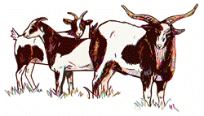 | Fainting Goat Guild  Performance Records

Exhibitors will wear the numbers in the ring that coincides with the candidate number.

Note to exhibitor: Do not worry about formatting or making it pretty. FGG will transfer your Champion Candidate’s information into a document that will be presented to the Judge.

Regional Champion Buck Candidates

Candidate #1 – age (add age) years (add Name)
 | Show Record | Show | Year
Self
Get A  (if applicable) | Add name
Get B  (if applicable) | Add name

Regional Champion Doe Candidates

Candidate #1 – age (add age) years (add Name)
 | Show Record | Show | Year
Self
Get A  (if applicable) | Add name
Get B  (if applicable) | Add name

Regional Champion Wether Candidates

Candidate #1 – age (add age) years (Name)
 | Show Record | Show | Year
Self
Activities
(if applicable)

